Mobile Application Development Lab

Course Outcome 2

Submitted By: Jomin K Mathew

20MCA321

GitHub Link: https://github.com/TKM-MCA-2020-MOBILE-DEV-LAB/20MCA221-JOMIN-K-MATHEW/tree/master/Course%20Outcome%201

1. Design a registration activity and store registration details in local memory of phone using Intents and SharedPreferences.

Activity_main.xml:

<?xml version="1.0" encoding="utf-8"?>

<LinearLayout xmlns:android="http://schemas.android.com/apk/res/android"

xmlns:app="http://schemas.android.com/apk/res-auto"

xmlns:tools="http://schemas.android.com/tools"

android:layout_width="match_parent"

android:layout_height="match_parent"

android:orientation="vertical"

tools:context=".MainActivity" >

<TextView

android:id="@+id/textView"

android:layout_width="match_parent"

android:layout_height="wrap_content"

android:fontFamily="@font/baloo_tamma"

android:text="Registration Detail"

android:textColor="#674646"

android:textSize="20sp" />

<EditText

android:id="@+id/name"

android:layout_width="match_parent"

android:layout_height="wrap_content"

android:ems="10"

android:hint="Enter the name"

android:inputType="textPersonName" />

<EditText

android:id="@+id/num"

android:layout_width="match_parent"

android:layout_height="wrap_content"

android:ems="10"

android:hint="Enter the phone number"

android:inputType="phone" />

<EditText

android:id="@+id/email"

android:layout_width="match_parent"

android:layout_height="wrap_content"

android:ems="10"

android:hint="Enter the email"

android:inputType="textEmailAddress" />

<Button

android:id="@+id/button"

android:layout_width="match_parent"

android:layout_height="wrap_content"

android:onClick="onSubmit"

android:text="Submit"

tools:ignore="OnClick" />

</LinearLayout>

Activity_main3.xml:

<?xml version="1.0" encoding="utf-8"?>

<LinearLayout xmlns:android="http://schemas.android.com/apk/res/android"

android:layout_width="match_parent"

android:layout_height="match_parent"

android:orientation="vertical" >

<TextView

android:id="@+id/textView4"

android:layout_width="match_parent"

android:layout_height="35dp"

android:fontFamily="@font/autour_one"

android:text="Submitted Details"

android:textColor="#9A4848"

android:textSize="20sp" />

<TextView

android:id="@+id/text1"

android:layout_width="match_parent"

android:layout_height="39dp"

android:text="TextView" />

<TextView

android:id="@+id/text2"

android:layout_width="match_parent"

android:layout_height="44dp"

android:text="TextView" />

<TextView

android:id="@+id/text3"

android:layout_width="match_parent"

android:layout_height="52dp"

android:text="TextView" />

<Button

android:id="@+id/button2"

android:layout_width="match_parent"

android:layout_height="wrap_content"

android:onClick="onSubmit"

android:text="Back" />

</LinearLayout>

MainActivity.java:

package com.example.storedetail;

import androidx.appcompat.app.AppCompatActivity;

import android.content.Intent;

import android.content.SharedPreferences;

import android.os.Bundle;

import android.view.View;

import android.widget.EditText;

public class MainActivity extends AppCompatActivity {

String Name,Phone,Email;

@Override

protected void onCreate(Bundle savedInstanceState) {

super.onCreate(savedInstanceState);

setContentView(R.layout.activity_main);

}

public void onSubmit(View view){

EditText name = (EditText) findViewById(R.id.name);

EditText phone = (EditText) findViewById(R.id.num);

EditText email = (EditText) findViewById(R.id.email);

Intent i = new Intent(getApplicationContext(),MainActivity3.class);

Name= name.getText().toString();

Phone = phone.getText().toString();

Email = email.getText().toString();

SharedPreferences sharedPreferences = getSharedPreferences("MySharedPref",MODE_PRIVATE);

SharedPreferences.Editor myEdit = sharedPreferences.edit();

myEdit.putString("name", name.getText().toString());

myEdit.putString("phone", phone.getText().toString());

myEdit.putString("email", email.getText().toString());

myEdit.apply();

i.putExtra("Name",Name);

i.putExtra("Phone",Phone);

i.putExtra("Email",Email);

startActivity(i);

}

@Override

protected void onResume() {

super.onResume();

EditText name = (EditText) findViewById(R.id.name);

EditText phone = (EditText) findViewById(R.id.num);

EditText email = (EditText) findViewById(R.id.email);

SharedPreferences sh = getSharedPreferences("MySharedPref", MODE_PRIVATE);

name.setText(sh.getString("name",""));

phone.setText(sh.getString("phone",""));

email.setText(sh.getString("email","")); }}

MainActivity3.java:

package com.example.storedetail;

import androidx.appcompat.app.AppCompatActivity;

import android.content.Intent;

import android.os.Bundle;

import android.view.View;

import android.widget.EditText;

import android.widget.TextView;

import android.widget.Button;

public class MainActivity3 extends AppCompatActivity {

Button b1;

@Override

protected void onCreate(Bundle savedInstanceState) {

super.onCreate(savedInstanceState);

setContentView(R.layout.activity_main3);

TextView t1 = (TextView) findViewById(R.id.text1);

TextView t2 = (TextView) findViewById(R.id.text2);

TextView t3 = (TextView) findViewById(R.id.text3);

Bundle extras = getIntent().getExtras();

String text1 = extras.getString("Name");

String text2 = extras.getString("Phone");

String text3 = extras.getString("Email");

t1.setText(text1);

t2.setText(text2);

t3.setText(text3);

}

public void onSubmit(View view) {

Intent i = new Intent(getApplicationContext(), MainActivity.class);

startActivity(i);

}

}

Output:

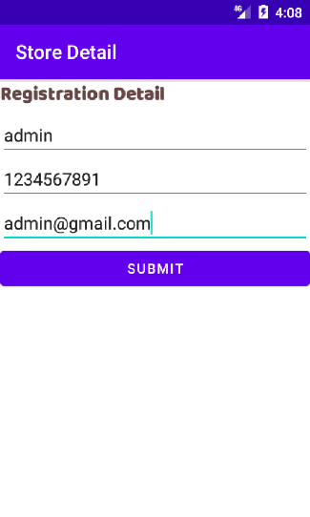 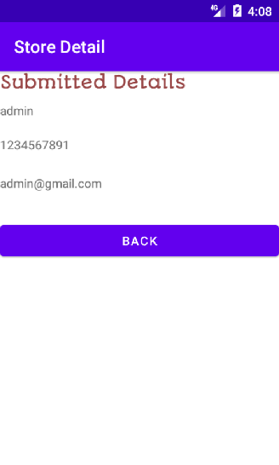

1. Design a simple Calculator using GridLayout and Cascaded LinearLayout.

Activity_main.xml:

<?xml version="1.0" encoding="utf-8"?>

<androidx.constraintlayout.widget.ConstraintLayout xmlns:android="http://schemas.android.com/apk/res/android"

xmlns:app="http://schemas.android.com/apk/res-auto"

xmlns:tools="http://schemas.android.com/tools"

android:layout_width="match_parent"

android:layout_height="match_parent"

android:background="#FFFFFF"

tools:context=".MainActivity">

<android.widget.GridLayout

android:id="@+id/gridLayout"

android:layout_width="398dp"

android:layout_height="496dp"

android:layout_marginStart="1dp"

android:layout_marginTop="52dp"

android:layout_marginEnd="1dp"

app:layout_constraintEnd_toEndOf="parent"

app:layout_constraintHorizontal_bias="1.0"

app:layout_constraintStart_toStartOf="parent"

app:layout_constraintTop_toBottomOf="@+id/edt1">

<Button

android:id="@+id/button2"

android:layout_width="wrap_content"

android:layout_height="60dp"

android:text="C"

android:textSize="20sp"

app:layout_column="0"

app:layout_row="0" />

<Button

android:id="@+id/button3"

android:layout_width="wrap_content"

android:layout_height="60dp"

android:text="( )"

android:textSize="20sp"

app:layout_column="1"

app:layout_row="0" />

<Button

android:id="@+id/button4"

android:layout_width="wrap_content"

android:layout_height="60dp"

android:text="%"

android:textSize="20sp"

app:layout_column="2"

app:layout_row="0" />

<Button

android:id="@+id/button5"

android:layout_width="wrap_content"

android:layout_height="59dp"

android:layout_row="0"

android:layout_column="3"

android:text="/"

android:textSize="20sp"

app:layout_column="3"

app:layout_row="0" />

<Button

android:id="@+id/button6"

android:layout_width="91dp"

android:layout_height="59dp"

android:layout_row="1"

android:layout_column="0"

android:text="7"

android:textSize="20sp"

app:layout_column="0"

app:layout_row="1" />

<Button

android:id="@+id/button7"

android:layout_width="wrap_content"

android:layout_height="60dp"

android:layout_row="2"

android:layout_column="0"

android:text="4"

android:textSize="20sp"

app:layout_column="0"

app:layout_row="2" />

<Button

android:id="@+id/button8"

android:layout_width="wrap_content"

android:layout_height="61dp"

android:layout_row="3"

android:layout_column="0"

android:text="1"

android:textSize="20sp"

app:layout_column="0"

app:layout_row="3" />

<Button

android:id="@+id/button9"

android:layout_width="wrap_content"

android:layout_height="59dp"

android:layout_row="4"

android:layout_column="2"

android:text="Del"

android:textSize="20sp"

app:layout_column="0"

app:layout_row="4" />

<Button

android:id="@+id/button10"

android:layout_width="wrap_content"

android:layout_height="61dp"

android:layout_row="1"

android:layout_column="1"

android:text="8"

android:textSize="20sp"

app:layout_column="1"

app:layout_row="1" />

<Button

android:id="@+id/button11"

android:layout_width="wrap_content"

android:layout_height="59dp"

android:layout_row="1"

android:layout_column="2"

android:text="9"

android:textSize="20sp"

app:layout_column="2"

app:layout_row="1" />

<Button

android:id="@+id/button12"

android:layout_width="wrap_content"

android:layout_height="62dp"

android:layout_row="1"

android:layout_column="3"

android:text="*"

android:textSize="20sp"

app:layout_column="3"

app:layout_row="1" />

<Button

android:id="@+id/button13"

android:layout_width="wrap_content"

android:layout_height="61dp"

android:layout_row="2"

android:layout_column="1"

android:text="5"

android:textSize="20sp"

app:layout_column="1"

app:layout_row="2" />

<Button

android:id="@+id/button14"

android:layout_width="wrap_content"

android:layout_height="64dp"

android:layout_row="3"

android:layout_column="1"

android:text="2"

android:textSize="20sp"

app:layout_column="1"

app:layout_row="3" />

<Button

android:id="@+id/button15"

android:layout_width="wrap_content"

android:layout_height="60dp"

android:layout_row="4"

android:layout_column="0"

android:text="0"

android:textSize="20sp"

app:layout_column="1"

app:layout_row="4" />

<Button

android:id="@+id/button16"

android:layout_width="wrap_content"

android:layout_height="60dp"

android:layout_row="2"

android:layout_column="2"

android:text="6"

android:textSize="20sp"

app:layout_column="2"

app:layout_row="2" />

<Button

android:id="@+id/button17"

android:layout_width="wrap_content"

android:layout_height="61dp"

android:layout_row="2"

android:layout_column="3"

android:text="-"

android:textSize="20sp"

app:layout_column="3"

app:layout_row="2" />

<Button

android:id="@+id/button18"

android:layout_width="wrap_content"

android:layout_height="59dp"

android:layout_row="3"

android:layout_column="2"

android:text="3"

android:textSize="20sp"

app:layout_column="2"

app:layout_row="3" />

<Button

android:id="@+id/button19"

android:layout_width="wrap_content"

android:layout_height="62dp"

android:layout_row="4"

android:layout_column="1"

android:text="."

android:textSize="24sp"

app:layout_column="2"

app:layout_row="4" />

<Button

android:id="@+id/button20"

android:layout_width="wrap_content"

android:layout_height="61dp"

android:layout_row="3"

android:layout_column="3"

android:text="+"

android:textSize="20sp"

app:layout_column="3"

app:layout_row="3" />

<Button

android:id="@+id/button21"

android:layout_width="wrap_content"

android:layout_height="60dp"

android:layout_row="4"

android:layout_column="3"

android:text="="

android:textSize="20sp"

app:layout_column="3"

app:layout_row="4" />

</android.widget.GridLayout>

<EditText

android:id="@+id/edt1"

android:layout_width="423dp"

android:layout_height="93dp"

android:layout_marginTop="140dp"

android:layout_marginBottom="95dp"

android:background="#FFFFFF"

android:backgroundTint="#D3D1D1"

android:textSize="34sp"

app:layout_constraintBottom_toTopOf="@+id/gridLayout"

app:layout_constraintEnd_toEndOf="parent"

app:layout_constraintHorizontal_bias="0.0"

app:layout_constraintStart_toStartOf="parent"

app:layout_constraintTop_toTopOf="parent"

app:layout_constraintVertical_bias="1.0"

tools:ignore="MissingConstraints" />

<EditText

android:id="@+id/editTextTextPersonName2"

android:layout_width="411dp"

android:layout_height="98dp"

android:layout_marginStart="1dp"

android:layout_marginTop="15dp"

android:layout_marginBottom="42dp"

android:background="#FFFFFF"

android:ems="10"

android:fontFamily="@font/anton"

android:foregroundGravity="center"

android:gravity="center"

android:inputType="textPersonName"

android:text="Calculator"

android:textColor="#42A3F6"

android:textSize="50sp"

android:textStyle="bold"

app:layout_constraintBottom_toTopOf="@+id/edt1"

app:layout_constraintEnd_toEndOf="parent"

app:layout_constraintHorizontal_bias="0.25"

app:layout_constraintStart_toStartOf="parent"

app:layout_constraintTop_toTopOf="parent"

app:layout_constraintVertical_bias="1.0" />

</androidx.constraintlayout.widget.ConstraintLayout>

MainActivity.java:

package com.example.calculatorgrid;

import androidx.appcompat.app.AppCompatActivity;

import android.os.Bundle;

import androidx.appcompat.app.AppCompatActivity;

import android.view.View;

import android.widget.Button;

import android.widget.EditText;

public class MainActivity extends AppCompatActivity {

Button button0, button1, button2, button3, button4, button5, button6,

button7, button8, button9, buttonAdd, buttonSub, buttonDivision,

buttonMul, buttond, buttonC, buttonEqual,buttonperc;

EditText cEditText;

float mValueOne, mValueTwo;

boolean cAddition, mSubtract, cMultiplication, cDivision,cperc;

@Override

protected void onCreate(Bundle savedInstanceState) {

super.onCreate(savedInstanceState);

setContentView(R.layout.activity_main);

button0 = (Button) findViewById(R.id.button15);

button1 = (Button) findViewById(R.id.button8);

button2 = (Button) findViewById(R.id.button14);

button3 = (Button) findViewById(R.id.button18);

button4 = (Button) findViewById(R.id.button7);

button5 = (Button) findViewById(R.id.button13);

button6 = (Button) findViewById(R.id.button16);

button7 = (Button) findViewById(R.id.button6);

button8 = (Button) findViewById(R.id.button10);

button9 = (Button) findViewById(R.id.button11);

buttond = (Button) findViewById(R.id.button19);

buttonAdd = (Button) findViewById(R.id.button20);

buttonSub = (Button) findViewById(R.id.button17);

buttonMul = (Button) findViewById(R.id.button12);

buttonDivision = (Button) findViewById(R.id.button5);

buttonC = (Button) findViewById(R.id.button2);

buttonperc = (Button) findViewById(R.id.button4);

buttonEqual = (Button) findViewById(R.id.button21);

cEditText = (EditText) findViewById(R.id.edt1);

button1.setOnClickListener(new View.OnClickListener() {

@Override

public void onClick(View v) {

cEditText.setText(cEditText.getText() + "1");

}

});

button2.setOnClickListener(new View.OnClickListener() {

@Override

public void onClick(View v) {

cEditText.setText(cEditText.getText() + "2");

}

});

button3.setOnClickListener(new View.OnClickListener() {

@Override

public void onClick(View v) {

cEditText.setText(cEditText.getText() + "3");

}

});

button4.setOnClickListener(new View.OnClickListener() {

@Override

public void onClick(View v) {

cEditText.setText(cEditText.getText() + "4");

}

});

button5.setOnClickListener(new View.OnClickListener() {

@Override

public void onClick(View v) {

cEditText.setText(cEditText.getText() + "5");

}

});

button6.setOnClickListener(new View.OnClickListener() {

@Override

public void onClick(View v) {

cEditText.setText(cEditText.getText() + "6");

}

});

button7.setOnClickListener(new View.OnClickListener() {

@Override

public void onClick(View v) {

cEditText.setText(cEditText.getText() + "7");

}

});

button8.setOnClickListener(new View.OnClickListener() {

@Override

public void onClick(View v) {

cEditText.setText(cEditText.getText() + "8");

}

});

button9.setOnClickListener(new View.OnClickListener() {

@Override

public void onClick(View v) {

cEditText.setText(cEditText.getText() + "9");

}

});

button0.setOnClickListener(new View.OnClickListener() {

@Override

public void onClick(View v) {

cEditText.setText(cEditText.getText() + "0");

}

});

buttonAdd.setOnClickListener(new View.OnClickListener() {

@Override

public void onClick(View v) {

if (cEditText == null) {

cEditText.setText("");

} else {

mValueOne = Float.parseFloat(cEditText.getText() + "");

cAddition = true;

cEditText.setText(null);

}

}

});

buttonSub.setOnClickListener(new View.OnClickListener() {

@Override

public void onClick(View v) {

mValueOne = Float.parseFloat(cEditText.getText() + "");

mSubtract = true;

cEditText.setText(null);

}

});

buttonMul.setOnClickListener(new View.OnClickListener() {

@Override

public void onClick(View v) {

mValueOne = Float.parseFloat(cEditText.getText() + "");

cMultiplication = true;

cEditText.setText(null);

}

});

buttonDivision.setOnClickListener(new View.OnClickListener() {

@Override

public void onClick(View v) {

mValueOne = Float.parseFloat(cEditText.getText() + "");

cDivision = true;

cEditText.setText(null);

}

});

buttonperc.setOnClickListener(new View.OnClickListener() {

@Override

public void onClick(View v) {

mValueOne = Float.parseFloat(cEditText.getText() + "");

cperc = true;

cEditText.setText(null);

}

});

buttonEqual.setOnClickListener(new View.OnClickListener() {

@Override

public void onClick(View v) {

mValueTwo = Float.parseFloat(cEditText.getText() + "");

if (cAddition == true) {

cEditText.setText(mValueOne + mValueTwo + "");

cAddition = false;

}

if (mSubtract == true) {

cEditText.setText(mValueOne - mValueTwo + "");

mSubtract = false;

}

if (cMultiplication == true) {

cEditText.setText(mValueOne * mValueTwo + "");

cMultiplication = false;

}

if (cDivision == true) {

cEditText.setText(mValueOne / mValueTwo + "");

cDivision = false;

}

if (cperc == true) {

cEditText.setText((mValueOne / mValueTwo)*100 + "");

cperc = false;

}

}

});

buttonC.setOnClickListener(new View.OnClickListener() {

@Override

public void onClick(View v) {

cEditText.setText("");

}

});

buttond.setOnClickListener(new View.OnClickListener() {

@Override

public void onClick(View v) {

cEditText.setText(cEditText.getText() + ".");

}

});

}

}

Output:

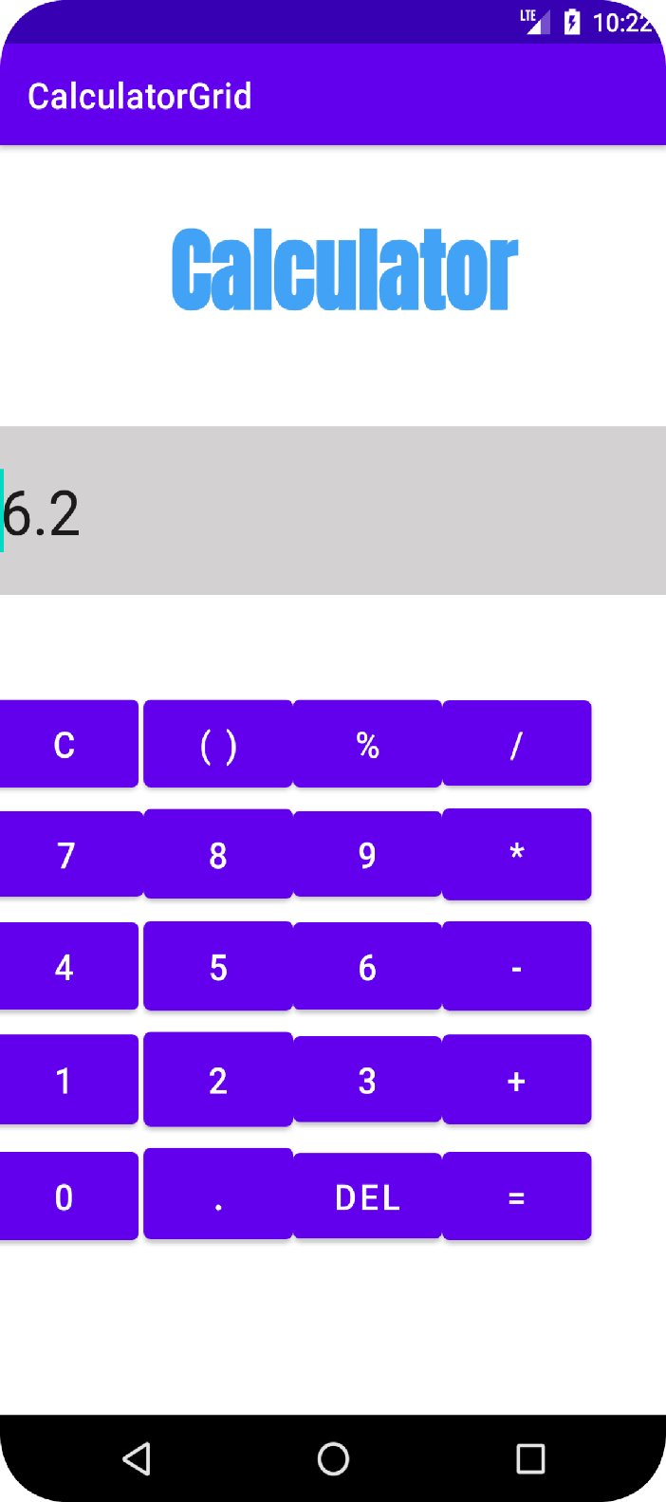

1. Create a Facebook page using RelativeLayout; set properties using .xml file

Activity_main.xml:

<?xml version="1.0" encoding="utf-8"?>

<RelativeLayout xmlns:android="http://schemas.android.com/apk/res/android"

xmlns:app="http://schemas.android.com/apk/res-auto"

xmlns:tools="http://schemas.android.com/tools"

android:layout_width="match_parent"

android:layout_height="match_parent"

android:background="#3A3939"

tools:context=".MainActivity">

<Button

android:id="@+id/button"

android:layout_width="314dp"

android:layout_height="wrap_content"

android:layout_alignParentStart="true"

android:layout_alignParentEnd="true"

android:layout_alignParentBottom="true"

android:layout_marginStart="55dp"

android:layout_marginEnd="41dp"

android:layout_marginBottom="97dp"

android:background="#1B678A"

android:backgroundTint="#082257"

android:foregroundTint="#602121"

android:text="Create New Facebook Account"

app:iconTint="#4E7CF3"

app:rippleColor="#4E1D1D" />

<TextView

android:id="@+id/textView"

android:layout_width="248dp"

android:layout_height="27dp"

android:layout_alignParentStart="true"

android:layout_alignParentTop="true"

android:layout_alignParentEnd="true"

android:layout_alignParentBottom="true"

android:layout_marginStart="131dp"

android:layout_marginTop="443dp"

android:layout_marginEnd="32dp"

android:layout_marginBottom="261dp"

android:fontFamily="@font/archivo_black"

android:text="Log Into Another Account"

android:textColor="#26E6EC"

android:textSize="14sp" />

<TextView

android:id="@+id/textView3"

android:layout_width="123dp"

android:layout_height="wrap_content"

android:layout_alignParentEnd="true"

android:layout_alignParentBottom="true"

android:layout_marginEnd="103dp"

android:layout_marginBottom="353dp"

android:fontFamily="@font/archivo_black"

android:text="Admin"

android:textColor="#26E6EC"

android:textSize="20sp" />

<TextView

android:id="@+id/textView2"

android:layout_width="wrap_content"

android:layout_height="wrap_content"

android:layout_alignParentStart="true"

android:layout_alignParentTop="true"

android:layout_alignParentEnd="true"

android:layout_alignParentBottom="true"

android:layout_marginStart="135dp"

android:layout_marginTop="498dp"

android:layout_marginEnd="74dp"

android:layout_marginBottom="206dp"

android:fontFamily="@font/archivo_black"

android:text="Find Your Account"

android:textColor="#26E6EC"

android:textSize="14sp" />

<ImageView

android:id="@+id/imageView2"

android:layout_width="wrap_content"

android:layout_height="wrap_content"

android:layout_alignParentStart="true"

android:layout_alignParentTop="true"

android:layout_alignParentEnd="true"

android:layout_alignParentBottom="true"

android:layout_marginStart="86dp"

android:layout_marginTop="493dp"

android:layout_marginEnd="293dp"

android:layout_marginBottom="206dp"

android:tint="#26E6EC"

app:srcCompat="@android:drawable/ic_menu_search" />

<ImageView

android:id="@+id/imageView3"

android:layout_width="43dp"

android:layout_height="46dp"

android:layout_alignParentStart="true"

android:layout_alignParentTop="true"

android:layout_alignParentEnd="true"

android:layout_alignParentBottom="true"

android:layout_marginStart="82dp"

android:layout_marginTop="430dp"

android:layout_marginEnd="286dp"

android:layout_marginBottom="255dp"

android:tint="#26E6EC"

app:srcCompat="@android:drawable/ic_input_add" />

<ImageView

android:id="@+id/imageView4"

android:layout_width="74dp"

android:layout_height="61dp"

android:layout_alignParentStart="true"

android:layout_alignParentTop="true"

android:layout_alignParentEnd="true"

android:layout_alignParentBottom="true"

android:layout_marginStart="96dp"

android:layout_marginTop="325dp"

android:layout_marginEnd="241dp"

android:layout_marginBottom="345dp"

app:srcCompat="@drawable/daco_5447989" /

<ImageView

android:id="@+id/imageView5"

android:layout_width="176dp"

android:layout_height="148dp"

android:layout_alignParentStart="true"

android:layout_alignParentTop="true"

android:layout_alignParentEnd="true"

android:layout_alignParentBottom="true"

android:layout_marginStart="117dp"

android:layout_marginTop="143dp"

android:layout_marginEnd="118dp"

android:layout_marginBottom="438dp"

android:tint="#FAFAFA"

app:srcCompat="@drawable/_8e91965eb97430e819064f5" />

</RelativeLayout>

MainActivity.java:

package com.example.facebookpage;

import androidx.appcompat.app.AppCompatActivity;

import android.os.Bundle;

public class MainActivity extends AppCompatActivity {

@Override

protected void onCreate(Bundle savedInstanceState) {

super.onCreate(savedInstanceState);

setContentView(R.layout.activity_main);

}

}

Output:

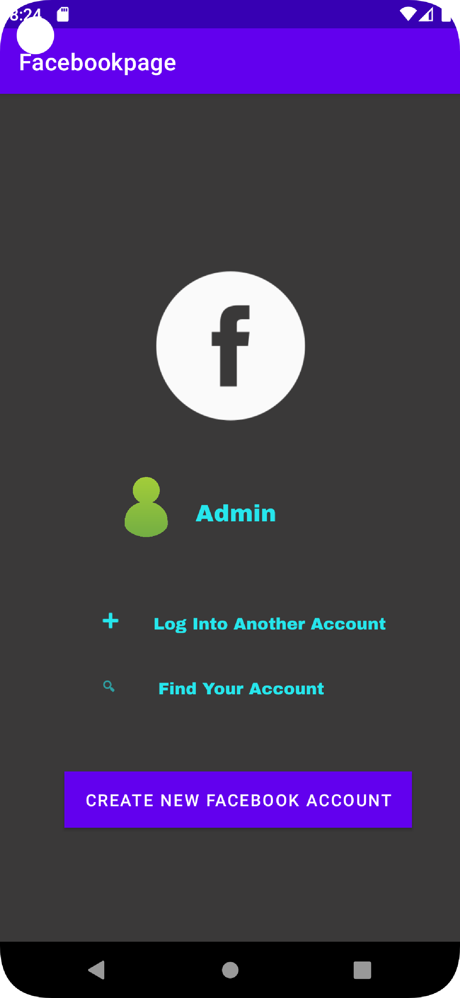

1. Develop an application that toggles image using FrameLayout

Activity_main.xml:

<?xml version="1.0" encoding="utf-8"?>

<FrameLayout xmlns:android="http://schemas.android.com/apk/res/android"

xmlns:app="http://schemas.android.com/apk/res-auto"

xmlns:tools="http://schemas.android.com/tools"

android:layout_width="match_parent"

android:layout_height="match_parent"

android:background="#BDBABA"

tools:context=".MainActivity">

<ImageView

android:id="@+id/imageView"

android:layout_width="wrap_content"

android:layout_height="wrap_content"

android:onClick="onClick"

app:srcCompat="@drawable/daco_5447989" />

<ImageView

android:id="@+id/imageView2"

android:layout_width="match_parent"

android:layout_height="match_parent"

android:onClick="onClick"

app:srcCompat="@drawable/_8e91965eb97430e819064f5" />

</FrameLayout>

MainActivity.java:

package com.example.framelayout;

import androidx.appcompat.app.AppCompatActivity;

import android.os.Bundle;

import android.view.View;

import android.widget.ImageView;

public class MainActivity extends AppCompatActivity implements View.OnClickListener {

ImageView i1,i2;

@Override

protected void onCreate(Bundle savedInstanceState) {

super.onCreate(savedInstanceState);

setContentView(R.layout.activity_main);

i1=(ImageView) findViewById(R.id.imageView);

i2=(ImageView) findViewById(R.id.imageView2);

i1.setOnClickListener(this);

i2.setOnClickListener(this);

}

@Override

public void onClick(View v) {

if(v.getId()==R.id.imageView)

{

i1.setVisibility(v.GONE);

i2.setVisibility(v.VISIBLE);

}

else

{

i2.setVisibility(v.GONE);

i1.setVisibility(v.VISIBLE);

}

}

}}

Output:

